Going to school
1.Write the benefits of going to school.
Ans. The benefits of going to school are-
# Acquiring knowledge and skills.
# Socializing with peers.
# Developing discipline and time management.
# Gaining a wider perspective of the world.
2.Describe the different landforms of India.
a). Northern mountains (Himalayas) –
These are the tallest mountains in the world, full of snow and glaciers, perfect for skiing.
b) Northern plains –
These are flat, fertile landswhere riverslike the Ganga and Brahmaputra flow perfect for growing yummy food.
c) Plateau –
A big, flat area in the south, made of old rocks with lots of rivers.
d). Thar desert –
A big,sandy desert in the west, where camels roam and the sun shines bright.
e) Coastal plains –
These are flat areas along the coast, where you can play in the sand and see the waves.
f) Islands –
An island is a piece of land that is completely surrounded by water, like a tiny land in a sea or river.
3. Do all children in our country reach their school same way ?
If no, mention the different ways by which children of our country reach their school.
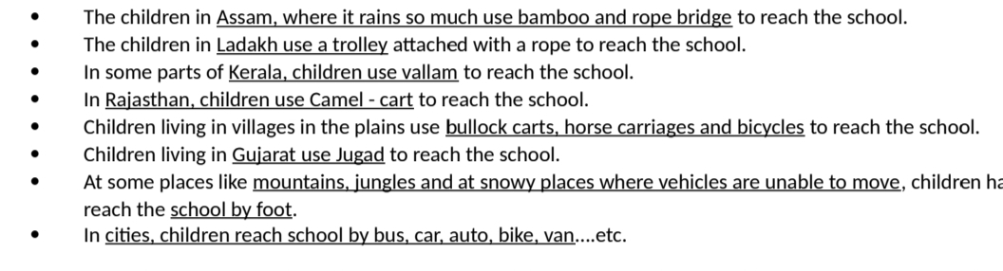
4. Write the difference between bamboo bridge and cement bridge.
Ans.
5. Write about a simple pulley, mentioning its uses in real life.
Ans. A pulley is a simple machine that uses a wheel and rope to lift heavy loads.
Example of use of pulley in our daily life –
- Drawing of water from a well.
- Raising a flag on a flagpole.
- Elevators
- Theatre curtains.
- Used in ropeway trolley
5.Mention the advantages of using a pulley in our daily life.
Ans. Advantages of using pulley:
- It reduces the efforts to lift ,pull or move an object.
- It also reduces the chances of a disaster .
- It also helps in changing the direction of heavy objects without much effort.
- Write about vallam and where it is used.
Ans.

